Business Law
Patent Sample Questions

- Brad owns a patent directed to a clamp for a watch. The patent describes the basic mechanics to securing the watch including clamping, locking, and buckling, and securing the watch. Angelina sells a watch using a securing method of using tie rope and button to secure the watch, similar to the method of closing the waist area of an overcoat. Brad argues that the Angelina’s watch infringes his patent because the described a “securing” method and Angelina’s watch has a “securing” method. Would Brad have a claim against Angelina’s watch?
(a) Yes. Brad’s watch clamp patent is a brilliant invention worthy of broad protection
(b) Yes. Brad’s watch clamp patent is enable and therefore enforceable.
(c) No. Brad’s watch clamp patent fails for lack of written description because Brad did not demonstrate possession of knowledge that tie rope and button could be used secure a watch.
(d) No. Brad’s clamp for a watch fails for lack of written description because he did not write down his invention.

- Bart owns a patent for smartwatch with a power button on the watch. In the specifications, Brad states that the power button is found on the side of the watch. The patent touts the advantages of the button as easily accessible and aesthetically pleasing and states this is the only place a power button can be placed. Homer manufacturers a smartwatch where the power controls is found underneath the watch. Would Bart have a claim against Homer for the power control?

- Yes. Bart clearly knew that power button can be located anywhere.
- Yes. Bart’s patent is enabled and not a natural phenomenon.
- No. Patent protection does not protect placement of power controls.
- No. Bart patent fails for lack of written description.

- The written description requirements can be found in what section of the U.S. code?

- 100
- 110
- 112
- 122

- Donald is at his gym working out and notices gripping dumbbells is easy and lifting weight plates is difficult. See images below. He surmises that it is because the handle used to grip and carry a dumbbell is better than the indent used on weight plates. Donald therefore files and obtains a patent for plates with dumbbell grips as seen below. Donald visits the Hillary Gym and notices that Hillary just began offering similar weight plates as those patented by Donald. Donald files a lawsuit against Hillary and Hillary defends on the ground that the Donald’s patent is “obvious.” Which of the following will best support Donald’s position that his invention is not obvious?

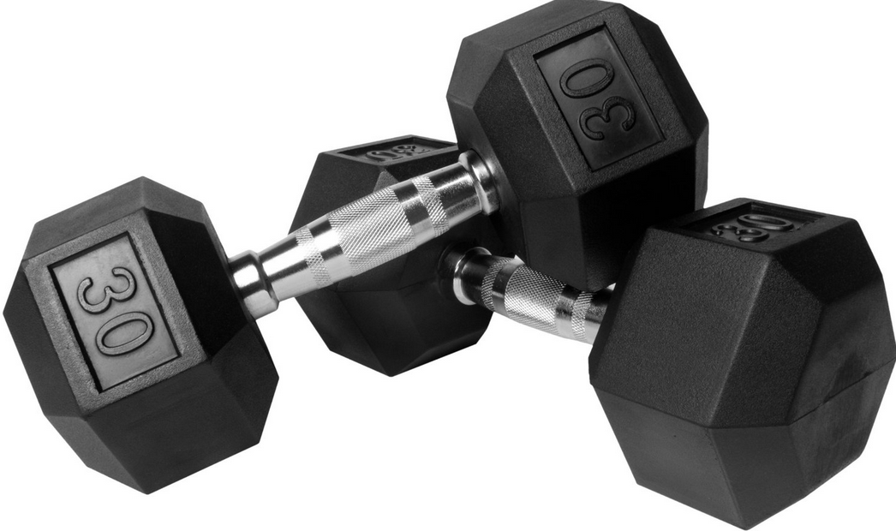
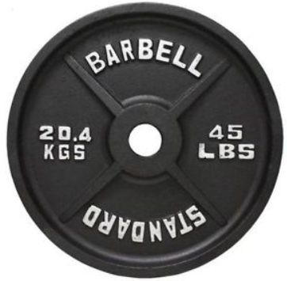
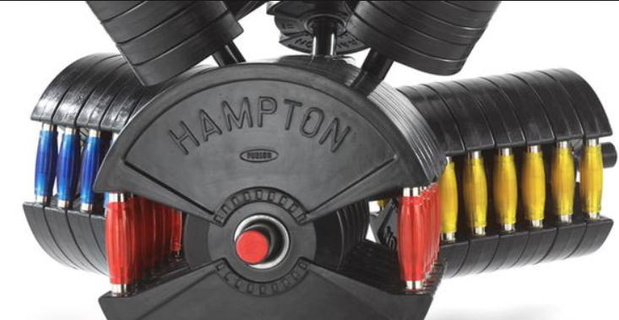

- People using Donald’s weights gets bigger and stronger than the traditional weights.
- Leading publications on weights hails Donald’s invention as ground breaking.
- Hillary stating that he thought of the idea years before Donald obtained his patent.
- People stating that they were visiting Hillary’s gym because they through it was approved by Donald.

- Donald sends a full description of his invention to Hillary, a businesswoman who is known to provide start-up funding to entrepreneurs, by an email sent on Monday, January 15, 2016. The letter is fully enabling of the invention. There is no confidentially agreement or duty to keep the information confidential between Donald and Hillary. When is the latest Donald can file a patent application and the invention not be rendered unpatentable because the invention is not “new”?

- Donald must file a provisional or non-provisional application the same day on Jan. 15, 2016 when the email was sent.
- Donald must have filed a provisional or non-provisional application by Jan. 14, 2016 (day before sending the email).
- Donald has until January 14, 2017 to file a provisional application and January 14, 2018 to file a non-provisional application.
- Donald can file a provisional or non-provisional application at any time.

- Brad invents a new way to clamp a bra that makes it easy to wear and remove. He creates a working prototype of the bra and shows it to his business partner, Angelina. She likes the bra so much that she beings wearing it every day, including while shopping and going to restaurants. Which of the following statements is accurate about the public disclosure of the bra?

- Using the bra is sufficient to render the invention not “new” after 1 year from the date Angelina wears the bra in public.
- As long as Angelina has the bra concealed under her clothing, the invention remains “new” for purposes of patenting the invention.
- Clamps for bras are not protectable subject matter under patent law.
- Angelina can only publicly disclose the bra if she shows it to the public.

- Which of the following is not part of the Graham test for obviousness?

- the scope and content of the prior art
- the differences between the claimed invention
- the similarities between the claimed invention
- the level of ordinary skill in the art

- Which of the following is not a characteristic of the specifications in a patent?

- It is a written description of the invention
- Must be full, clear, concise, and exact terms to enable a person skilled in the art to make and use the invention
- The specification is used to interpret and understand the claims
- Specifications include all the elements of the claims

- Who decides the claim construction (i.e. what the claim means)?

- Judge
- Jury
- Attorney
- Public

- How long does a utility patent last?

- 17 years from the date the patent is issued
- 20 years from the date the patent application is filed
- 20 years from the date the patent is issued
- The life if the inventor and 70 years

- A person can infringe a patent by all of the following except:

- Using a product with the invention for his own personal use
- Making a product with the invention in order to research its technical effectiveness
- Selling a product with the invention in order to profit from the product
- Publishing drawings of the product with the invention on a website

- Which of the following is not true concerning patentable subject matter:

- To be patentable subject matter, an invention must constitute a process, machine, manufacture, or composition of matter.
- The only relevant test for assessing patentable subject matter is whether the invention is man-made.
- New uses of previously known compositions are not patentable.
- Improvements on previously known devices are not patentable.

- What is the difference between a provision and non-provisional application?

- The provisional application lacks claims
- The provisional application does not need disclosures
- A non-provisional application need not contain drawings
- A non-provisional application can be filed 1 year prior to the provisional application

- What is the significance of 1 year after filing a provisional application?

- The provisional application automatically converts to a provisional application
- The provisional application will automatically be issued as a patent pending application
- The provisional application will be reassigned as a secondary provisional application
- The applicant must file a corresponding non-provisional application or lose the benefits of the provisional application

- Which of the following describes what a claim must accomplish?

- Establish the utility of the invention over prior art
- Describe how the invention is an improvement over the prior art
- Describe how to make and use the invention
- Describe the elements of the invention

- Which of the following best describes when the “written description” requirement is satisfied?

- The patent application is in writing
- The claims are based upon something that is written, as opposed to pictorial
- The claims are supported by the specification that indicates that the applicant was in possession of the claimed invention
- The application describes in writing how the invention was first conceived

- Which of the following best describes a situation where an invention would be barred by anticipation (section 102)?

- The invention was disclosed in an article published in the U.S.
- The invention as partially disclosed in one article and partially disclosed in a second article, but together they describe the invention.
- The invention was shown in a movie, but the movie did not enable the invention.
- The invention was known by someone in the U.S., although he never told anyone or wrote anything down.

- Which of the following best describes when a prior art reference anticipates an invention?

- Every element of the claimed invention is disclosed in a single prior art reference
- Every element of the claim invention is expressly disclosed in a single prior art reference
- Every element of the claimed invention is disclosed expressly or inherently in a claimed invention
- Every element of the claimed invention is disclosed inherently in a claimed invention

- How many prior art references may an obviousness rejection be based on?

- Obviousness must be based on at least two prior art references in the same field of art
- Obviousness must be based on one prior art and the inherency from the prior art
- Obviousness must be based on any two prior art references
- Obviousness must be based on the opinion of the public regardless of their skills or knowledge

- Who is considered an inventor of a patent?

- Anyone who was contributed to the invention and one of the claims
- Anyone who helps to make a physical embodiment of the invention
- Anyone who contributed only to the labor and supervision of routine techniques
- Anyone who wishes to put their name and reputation onto the issued patent

- Which of the following is not a patentable subject matter?

- Process
- Machine
- Article of manufacture
- Abstract ideas

22. Hillary invents a device that will detect whether another person is lying from a distance of 20 feet away. The device is a black box with circuitry and battery to last at least as long as a national debate. What is Hillary patenting if she patents the box?

- Process
- Machine
- Article of manufacturer
- Composition of matter

- Luke Skywalker is in the mist of fighting a large walking machine called an AT-AT intent on destroying an entrenched rebels fighting team. As the large walking machine approaches, Luke discovers that if you wrap cable around the legs and flies around more than five times, a starship pilot can render the large walking machine inoperable. If Luke decides to patent this invention, what is he patenting?

- Process
- Machine
- Article of manufacturer
- Composition of matter

- Another rebel fighter sees that Luke Skywalker rendered the large walking machine inoperable by wrapping cables. He realizes that if the cable had spikes, they would be more effective and could render the large walking machine inoperable in less time. What is this second rebel fighter patenting?

- Process
- Machine
- Article of manufacturer
- Composition of matter

- Finally, a third rebel fighter sees Luke Skywalker render the large walking machine inoperable and formulates an equation for rending these machines inoperable by deducing the force of the legs and tension of the cables similar to the pv=nrt equation. What can this third rebel fighter patent?

- Process
- Machine
- Article of manufacturer
- Nothing

- Midas discovers a way to synthesize lead into gold. What type of patent is Midas patenting?

- Process
- Machine
- Article of manufacturer
- Composition of matter

- Einstein discovers that E=MC². What type of patent can Einstein get for this equation?

- Process
- Machine
- Article of manufacturer
- Nothing

- Which of the following is not a consideration in adjusting for hindsight bias?

- Inspiration
- Teaching
- Suggestion
- Motivation

- Darth Vader has an idea for a Deathstar intended to destroy the rebel home base. He invents a specially coated glass used in conjunction with a laser that enhances the power of the laser. Darth Vader patents the specially coated glass and the rebels are trying to invalidate the patent. Specifically, the rebels argue that the special glass already existed in the medical industry in microscopes to see midi-chlorian, a small bacterial. Darth Vader’s best defense against his patent from being invalidated would be?

- Rebels, particularly those living on ice planets, are not to be trusted.
- The glass used in microscopes is non-analogous art
- The rebels cannot show any secondary prior art to render the invention obvious
- The microscope is not anticipatory because it was not used with lasers

- Which of the following secondary consideration would best suggest that a patented glow-in-the-dark yo-yo was nonobvious?

- The patented yo-yo sells well
- The yo-yo is praised by toy industry for its innovation
- Others have attempted to make a glow-in-the-dark yo-yo and failed
- All of the above

- Hillary discovers that putting a metal core into a golf ball helps the ball to travel further and roll better. She patents a golf ball with a metal core. Donald tests numerous metals to determine which metal core works the best and after experimenting with hundreds of metal and metal alloy, he finds that a mixture of lead and copper greatly improves the ball flight and rolling than any other metal. In fact, Donald learns that is the rigidity and electric conductivity that improves the performance of the golf ball, which is not necessarily found in all metals and not found to the same degree in all metals. Hillary sues Donald for patent infringement when he starts to sell his own golf balls with metal core. Which argument is likely to best help Donald defeat a claim for patent infringement?

- Ball flight and ball rolling are laws of nature and are not patentable.
- Hillary did not satisfy the best mode requirement as she did not identify which clubs works best with metal core golf balls.
- Hillary cannot patent a metal core golf ball because golf is not one of the patentable subject matter.
- Hillary patent is invalid for failure to enable the invention as evidence by Donald’s undue experimentation to identify the best metal core.

